This is a sample of the resources Legato Strategic Consulting provides through dedicated support to institutions like yours.

How to View Policies Configured to Academic Units

ABOUT THE ACADEMIC UNIT POLICY VIEWER

Users can use the Academic Unit Policy Viewer to view policies configured to academic units for the purposes of documentation, troubleshooting and system optimization.

Background: Most commonly, this viewer is used for one of two purposes:

- View policies configured to the institution academic unit only (not subordinate academic units) or
- View policies configured to all academic units, including both the institution academic unit and all subordinate units. (Recommended)

Use this reference to view policies configured to all academic units, including both the institution academic unit and related subunits.

Table of Contents:
(click to jump to content)
How to View Policies Configured to all Academic Units 2
How to Narrow Your Results 3
Filter to View Specific Policies Configured to Academic Units and Programs of Study 3
BONUS: View Details of Configurations 4

HOW TO VIEW POLICIES CONFIGURED TO ALL ACADEMIC UNITS

- In the search bar, type “Academic Unit Policy Viewer”. Click the task to open.

- In the Academic Unit Policy Viewer window, click “Academic Unit / Academic Level”.
Note: If you click “Institution”, only policies configured at the institution-level will display. Policies configured to subordinate academic units will be ommitted.

- In the Academic Unit field, select your institution.
Note: By selecting the institution, you can view policies configured to the institution. If you want to view a specific academic unit, you may select another option.

- Locate and check the Include Subordinate Academic Units and Program of Study box.
Note: By selecting this box, you will activate the viewer to include all subordinate units as well as all programs of study.

- In the Policies Effective As Of field, enter “01/01/1900”.

- Click OK.

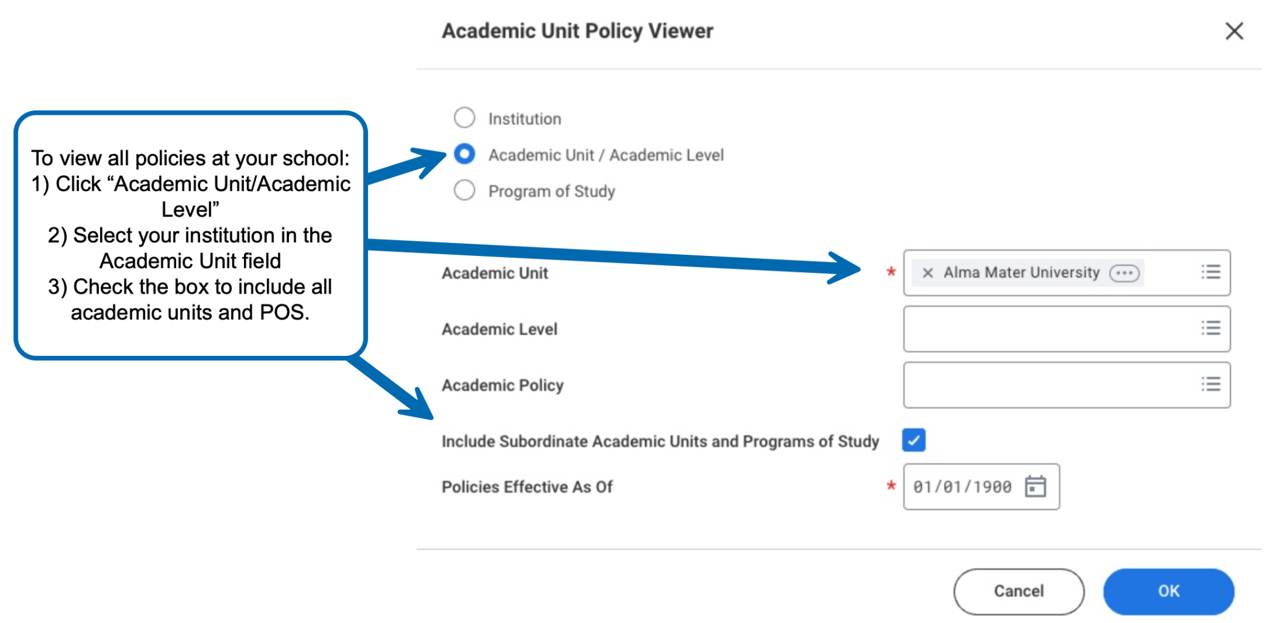

The results will display a row for each academic unit, academic level and/or program of study and corresponding policies.

HOW TO NARROW YOUR RESULTS
There are tools available to filter, sort and narrow your results. See below for available options:

Filter to View Specific Policies Configured to Academic Units and Programs of Study

Instructions:

- Toggle to return to the Academic Unit Policy Viewer window.

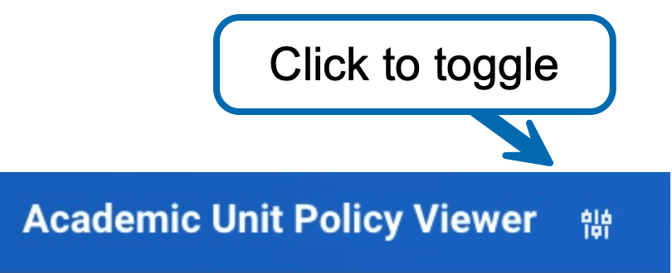

- Locate the Academic Policy field, and select a policy.

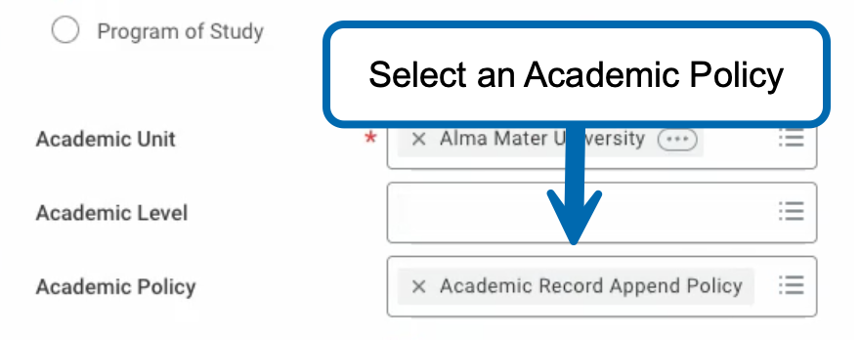

- Click “OK”.

- In the results table, click the Academic Unit Policy Snapshot column header. Click “Value” to display a summary of actual policies in use across all displayed rows. To filter, select a policy.

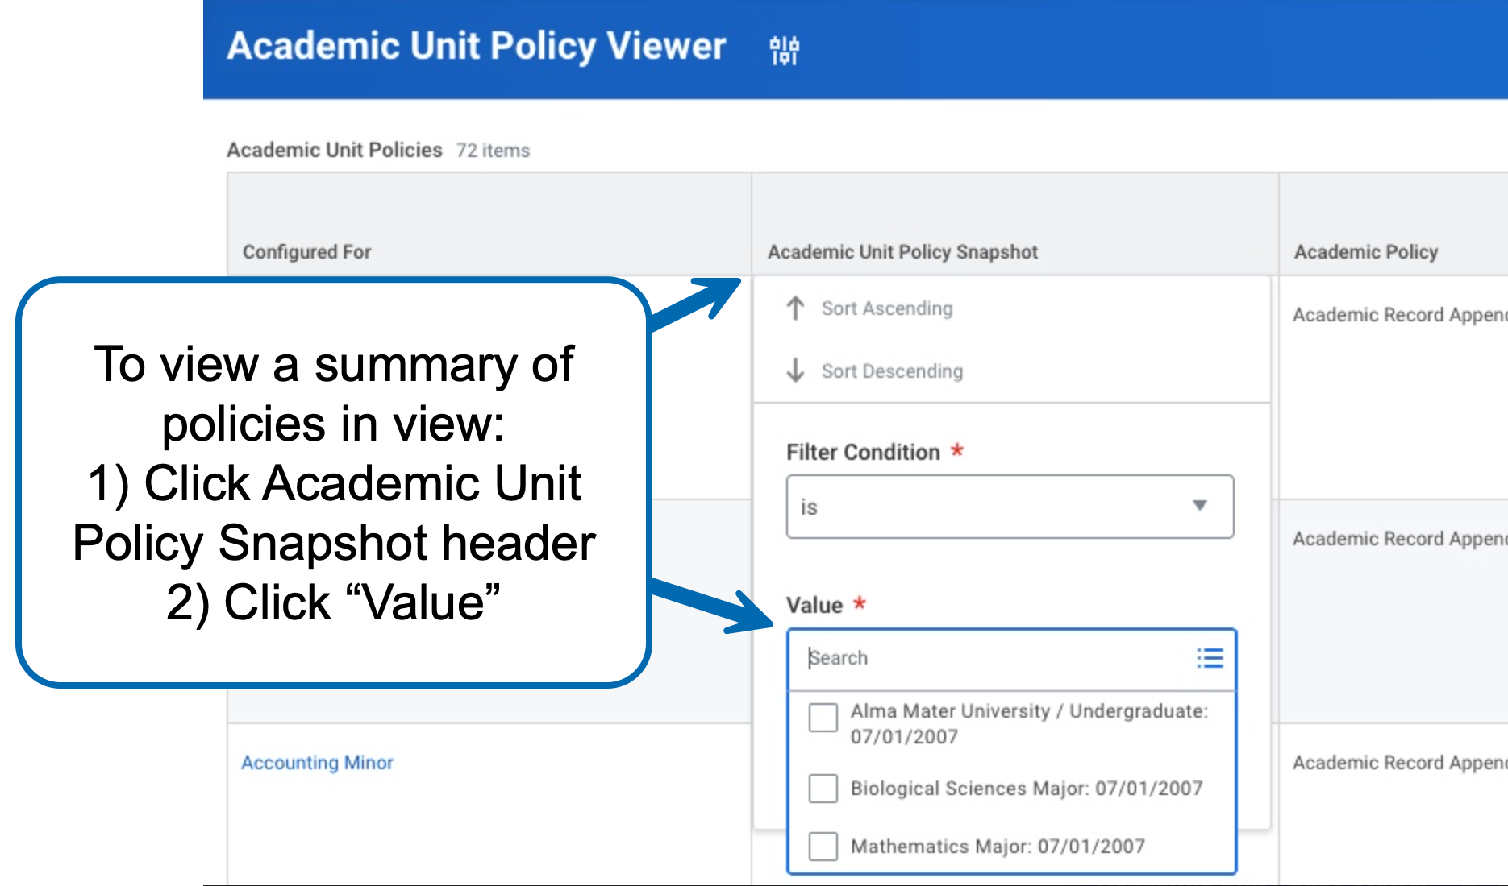

BONUS: VIEW DETAILS OF CONFIGURATIONS

Users can dig deeper into configuration details directly through the results table. Keep reading to learn how:

- Locate a configuration in the Academic Unit Policy Snapshot column.

- Right-click the configuration to open in a new tab.

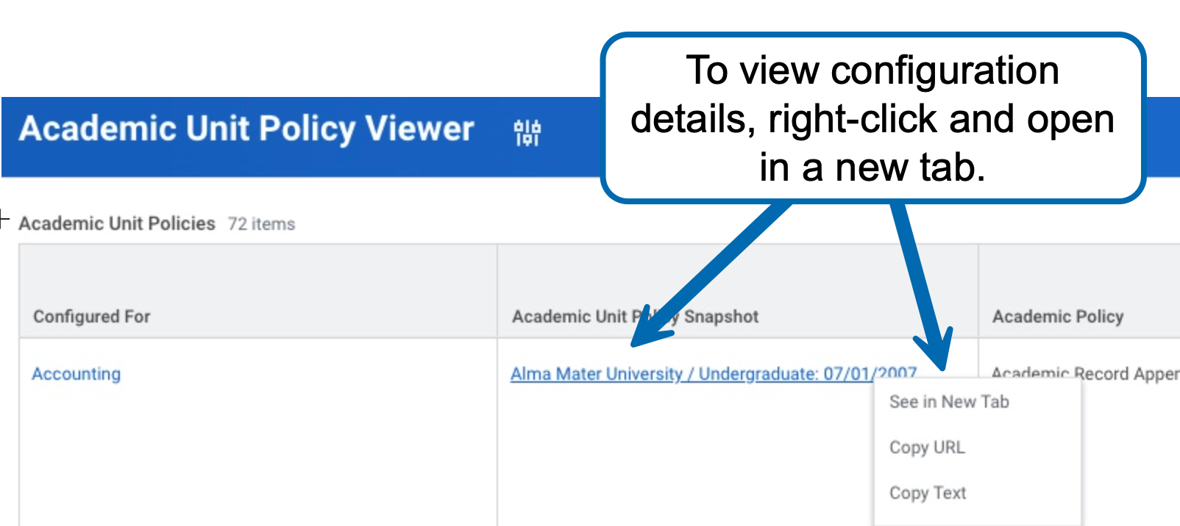

- Configuration details will display.
